**MISO Introduction.**

**MYSQL and APEX are free Oracle Products, lets not FEAR Oracle!**

**Oracle run 70% of the worlds database.**

We are going to demo, how to REST enable a schema and database objects in two ways,

1. Quick way (created AUTOMATIC RESTAPI for CRUD )
2. Right way (Lets you define them based on code you write)

Estimated Time: 10 minutes

**Background Information**

If it doesn’t already exist, then we will be creating the EMP and DEPT tables, REST enabling them, and then building an application all in the same schema. Normally, you would REST enable database objects in a remote database schema, and then utilize those REST endpoints to define REST Data Sources in an application, where APEX is installed, within the local database, as outlined below.

Once the REST Data Source is defined in an APEX application, rather than calling a local database object, the APEX Engine calls the REST endpoint, to retrieve the data from the remote database. If the PUT, POST, and DELETE handlers have also been defined, then APEX applications can also perform updates, inserts, and deletes on the remote database objects.

**Task 1: Creating the Sample Tables**

This lab utilizes the common EMP and DEPT tables. These can easily be installed using Sample Datasets.

1. Log into your workspace.
2. In the main menu, select **SQL Workshop**, select **Utilities**, click **Sample Datasets**.

1. In the list of Sample Datasets, on the EMP / DEPT row, click **Install**.

1. On the Manage Sample Dataset dialog, click **Next**.

1. On the Load Sample Dataset dialog, click **Install Dataset**.

1. On the Load Sample Dataset - Results dialog, click **Exit**.

*Note: We do not want to create an application directly on the tables.*

**IF (you had chosen to click on Create Application) the framework would have taken your table definitions and given you a Blueprint as below: ignore the blueprint, well discuss it later.**

|  |
| --- |
| {  "application": {    "name": "Demonstration - EMP / DEPT",    "appShortDescription": "Generated based on a Sample Dataset!",    "appDescription": "This application was generated directly from Sample Datasets. Go to SQL Workshop > Utilities > Sample Datasets to install tables and then create an application based on those tables.",    "schema": "MISODEVADMIN",    "features": {      "accessControl": true,      "activityReporting": true,      "configurationOptions": true,      "feedback": true,      "helpPages": true,      "themeSelection": true      },    "appearance": {      "themeStyle": "Vita",      "navigation": "SIDE",      "icon": "app-icon-people",      "iconBackgroundClass": "app-color-1",      "iconColorHEX": "#309FDB"      },    "settings": {      "baseTablePrefix": "",      "primaryLanguage": "en",      "authentication": "Application Express"      },    "pages": [      {        "page": "1",        "pageType": "blank",        "pageName": "Home",        "pageIcon": "fa-home",        "pageIsHomePage": true,        "help": ""      }      ,      {        "page": "2",        "pageType": "dashboard",        "pageName": "Dashboard",        "pageIcon": "fa-dashboard",        "help": "",        "dashboardWidgets": [        {          "name": "Employees per Department",          "type": "pie",          "table": "EMP_DEPT_V",          "labelColumn": "DNAME",          "valueColumn": "allColumns",          "valueDerivation": "count"        }        ,        {          "name": "Employees per Job",          "type": "pie",          "table": "EMP_DEPT_V",          "labelColumn": "JOB",          "valueColumn": "allColumns",          "valueDerivation": "count"        }        ,        {          "name": "Total Salary per Department",          "type": "bar",          "table": "EMP_DEPT_V",          "labelColumn": "DNAME",          "valueColumn": "SAL",          "valueDerivation": "sum"        }        ,        {          "name": "Total Salary per Job",          "type": "bar",          "table": "EMP_DEPT_V",          "labelColumn": "JOB",          "valueColumn": "SAL",          "valueDerivation": "sum"        }        ]      }      ,      {        "page": "3",        "pageType": "facetedSearch",        "pageName": "Employees",        "pageIcon": "fa-table-search",        "fsReportType": "CR",        "reportImplementation": "TABLE",        "table": "EMP",        "includeFormWithReport": true,        "help": ""      }      ,      {        "page": "4",        "pageType": "interactiveReport",        "pageName": "Departments",        "pageIcon": "fa-table",        "reportImplementation": "TABLE",        "table": "DEPT",        "includeFormWithReport": true,        "drillDownLinkColumn": "DNAME",        "drillDownLinkKey": "DEPTNO",        "linkToPage": "",        "linkToKey": "DEPTNO",        "help": ""      }      ],    "generalSettings": {      "builtWithLove": true,      "learnAppDefaults": false,      "version": "Release 1.0",      "logging": true,      "debugging": true      },    "globalizationSettings": {      "documentDirection": "left-to-right"      },    "securitySettings": {      "deepLinking": false,      "maximumSessionSeconds": "",      "maximumSessionIdleSeconds": ""      }    }  }  **Here is the UI based on the above json, build automatically with 1 CLICK !!** |

**If you were to click, “Create Application” then it would be so.**

**Here is what the development environment looks like.**

**Everything is bound inside of pages, the database stores state information, each page is rendered at real time and change is implemented, using data and metadata. If You click on the Run ICON, it will direct you to**

[**https://gd49ef7d5e3cd2d-apex21c.adb.us-phoenix-1.oraclecloudapps.com/ords/r/misodevadmin/demonstration-emp-dept**](https://gd49ef7d5e3cd2d-apex21c.adb.us-phoenix-1.oraclecloudapps.com/ords/r/misodevadmin/demonstration-emp-dept)

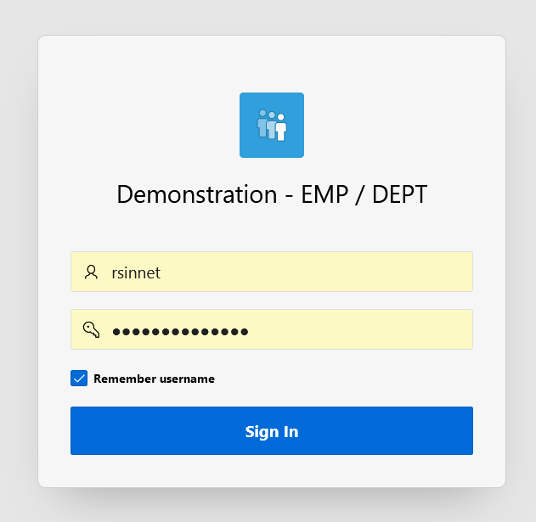

Users created nkosolobov/MisoSoup123!@#  
Users created rsinnet/MisoSoup123!@#  
Users created aplascencia/MisoSoup123!@#

**Click on the Hamburger to the left of the word “Demonstration”**

**It exposes the menus**

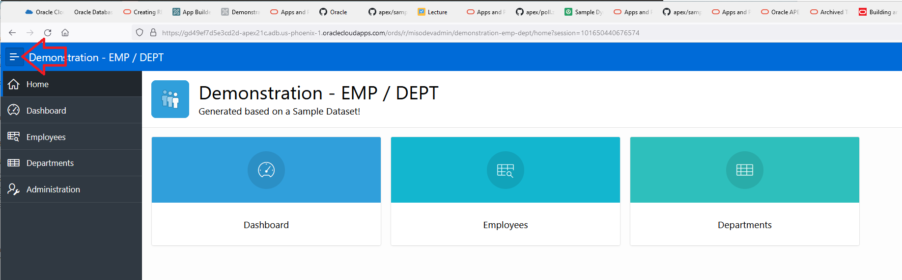

**Searchable, filterable fascets to drive user interface decisions.**

Click on Administration, it gives you metadata about what your users are doing with the system!

Your users and configure their own themes,in case they like their web pages to have funky colors.

See how each page is doing.

See what activites have been done by user.

If you’re the administer, you can add user to use this app.

**Get page based feedback by clicking on the cloud to the left of your login info.**

**If your developing the UI, you can make custom changes with your users until they find the appearance they like.**

**Here is the sql we built an app around.**

|  |
| --- |
| CREATE TABLE "DEPT"  ( "DEPTNO" NUMBER(2,0) NOT NULL ENABLE,  "DNAME" VARCHAR2(50) COLLATE "USING_NLS_COMP",  "LOC" VARCHAR2(50) COLLATE "USING_NLS_COMP",  CONSTRAINT "DEPT_PK" PRIMARY KEY ("DEPTNO")  USING INDEX ENABLE  ) DEFAULT COLLATION "USING_NLS_COMP"  /  CREATE TABLE "EMP"  ( "EMPNO" NUMBER(4,0) NOT NULL ENABLE,  "ENAME" VARCHAR2(50) COLLATE "USING_NLS_COMP",  "JOB" VARCHAR2(50) COLLATE "USING_NLS_COMP",  "MGR" NUMBER(4,0),  "HIREDATE" DATE,  "SAL" NUMBER(7,2),  "COMM" NUMBER(7,2),  "DEPTNO" NUMBER(2,0),  CONSTRAINT "EMP_PK" PRIMARY KEY ("EMPNO")  USING INDEX ENABLE  ) DEFAULT COLLATION "USING_NLS_COMP"  /  ALTER TABLE "EMP" ADD CONSTRAINT "EMP_MGR_FK" FOREIGN KEY ("MGR")  REFERENCES "EMP" ("EMPNO") ENABLE  /  ALTER TABLE "EMP" ADD CONSTRAINT "EMP_DEPT_FK" FOREIGN KEY ("DEPTNO")  REFERENCES "DEPT" ("DEPTNO") ENABLE  /  CREATE OR REPLACE FORCE EDITIONABLE VIEW "EMP_DEPT_V" ("EMPNO", "ENAME", "JOB", "MGR", "HIREDATE", "SAL", "COMM", "DEPTNO", "DNAME", "LOC") DEFAULT COLLATION "USING_NLS_COMP" AS  select e.empno  , e.ename  , e.job  , (select m.ename from emp m where e.mgr = m.empno) mgr  , e.hiredate  , e.sal  , e.comm  , d.deptno  , d.dname  , d.loc  from emp e  , dept d  where e.deptno = d.deptno (+)  / |

**Task 2: REST Enabling the Database Objects, the EASY WAY ☹**

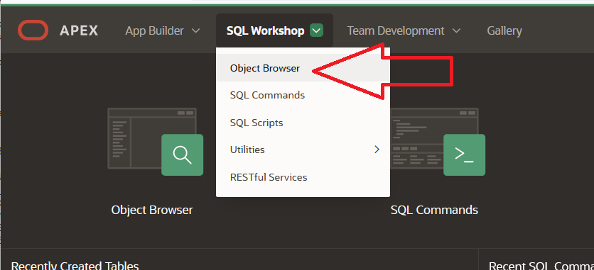

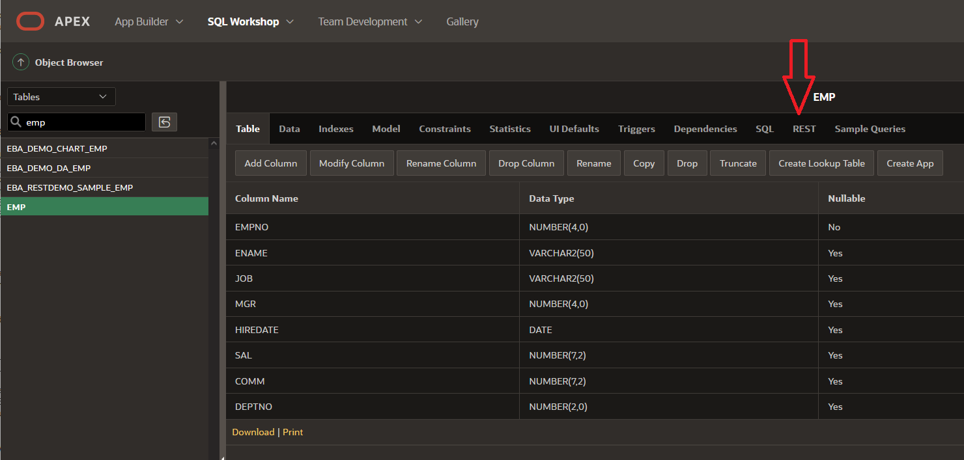

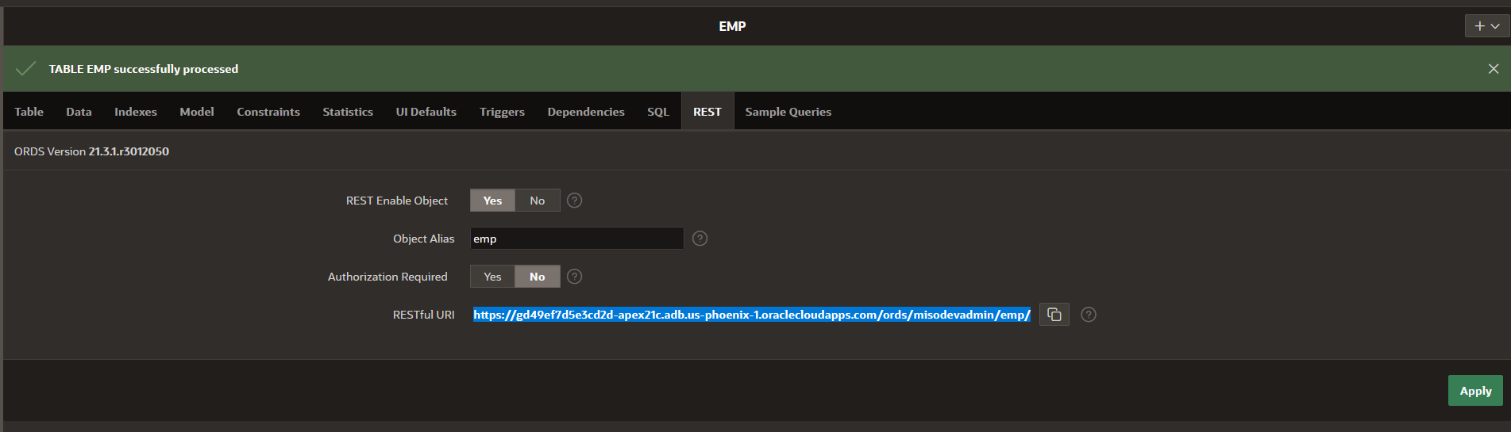

[**https://gd49ef7d5e3cd2d-apex21c.adb.us-phoenix-1.oraclecloudapps.com/ords/misodevadmin/emp/**](https://gd49ef7d5e3cd2d-apex21c.adb.us-phoenix-1.oraclecloudapps.com/ords/misodevadmin/emp/)

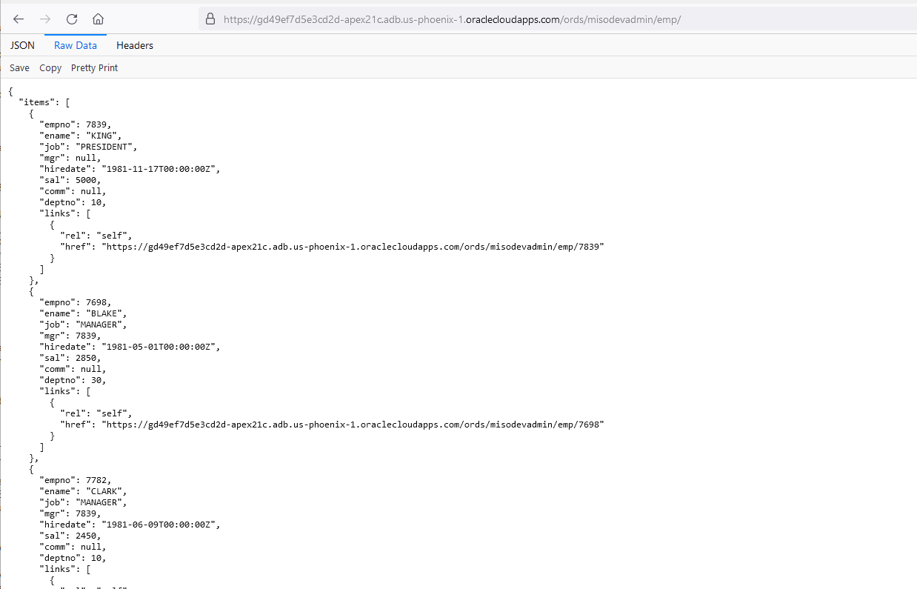

If we goto the admin pages for this schema.

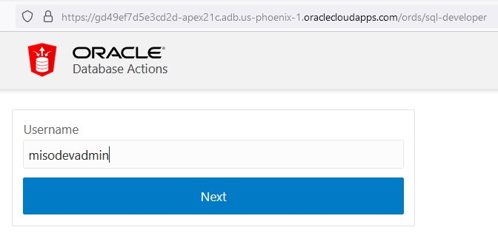

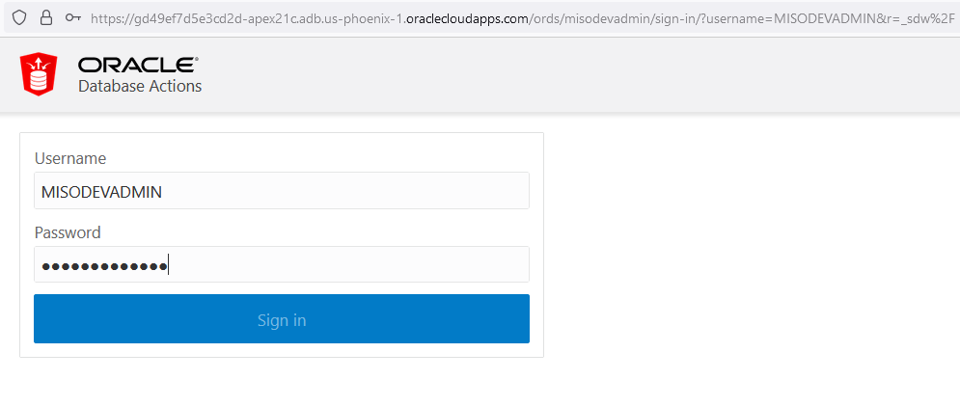

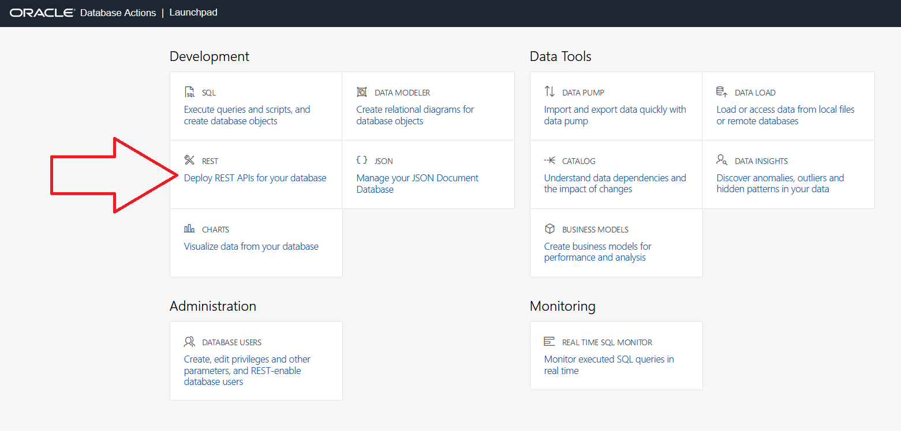

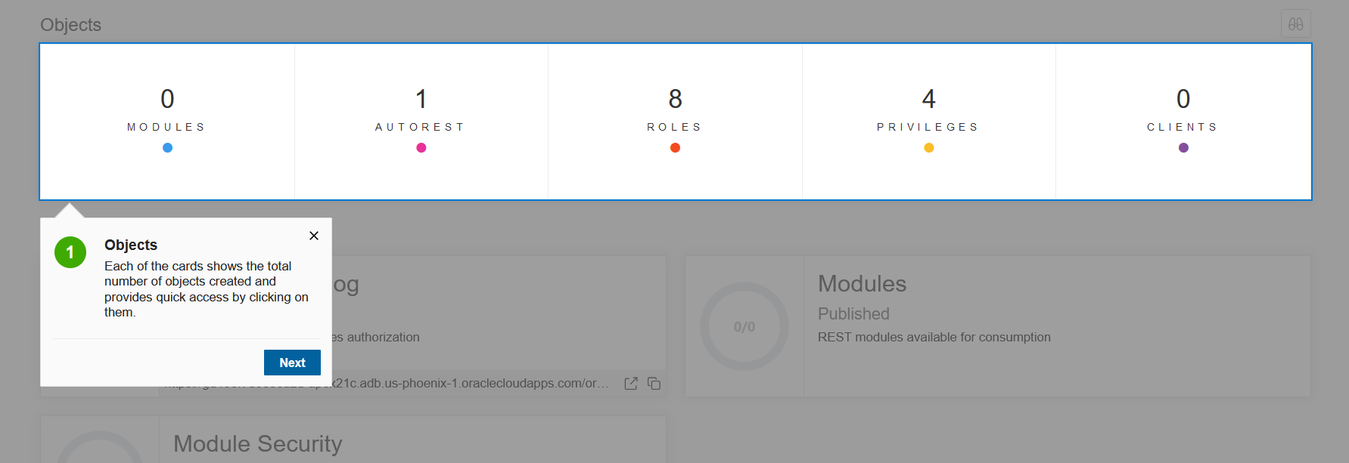

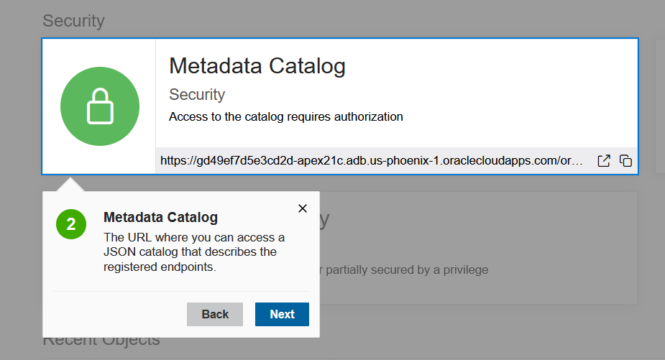

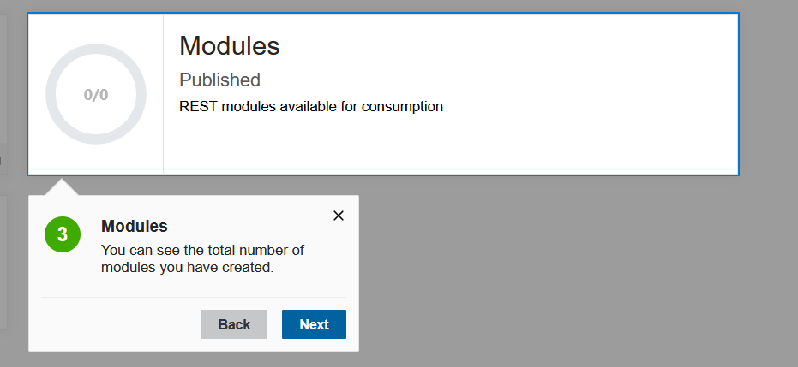

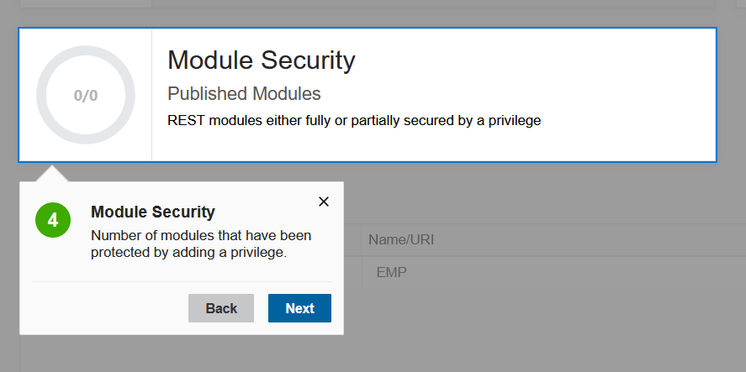

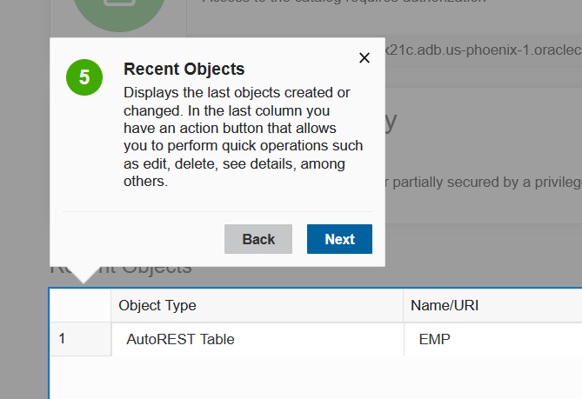

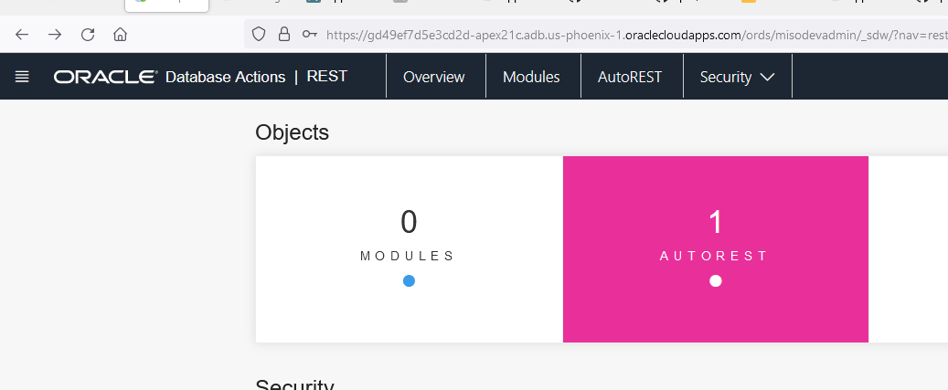

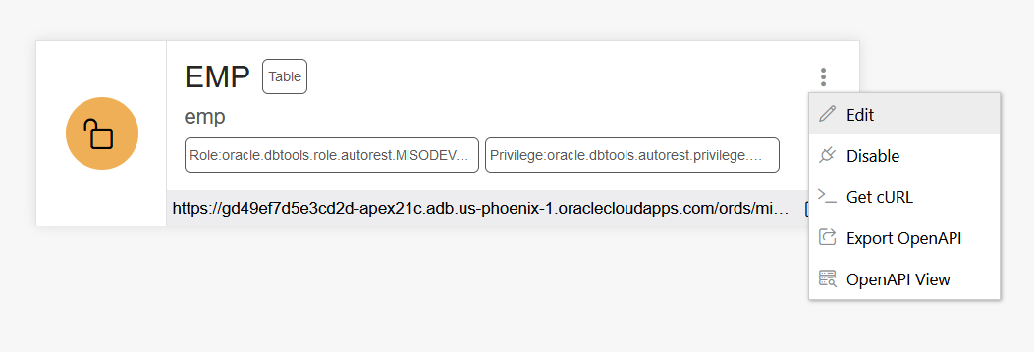

IF I click on Open API VIEW , I get this.

|  |  |  |  |  |  |  |  |  |  |  |  |  |  |  |  |  |  |  |  |  |  |  |  |  |  |  |  |  |  |  |  |  |  |  |  |  |  |  |  |  |  |  |  |  |  |  |  |  |  |  |  |  |  |  |  |  |  |  |  |  |  |  |  |  |
| --- | --- | --- | --- | --- | --- | --- | --- | --- | --- | --- | --- | --- | --- | --- | --- | --- | --- | --- | --- | --- | --- | --- | --- | --- | --- | --- | --- | --- | --- | --- | --- | --- | --- | --- | --- | --- | --- | --- | --- | --- | --- | --- | --- | --- | --- | --- | --- | --- | --- | --- | --- | --- | --- | --- | --- | --- | --- | --- | --- | --- | --- | --- | --- | --- |
| EMPTableemp  * Role:oracle.dbtools.role.autorest.MISODEVADMIN.EMP * Privilege:oracle.dbtools.autorest.privilege.MISODEVADMIN.EMP   https://gd49ef7d5e3cd2d-apex21c.adb.us-phoenix-1.oraclecloudapps.com/ords/misodevadmin/emp ORDS generated API for EMP **1.0.0**  Schemes default GET​/  Retrieve records from EMP Parameters No parameters Responses Response content type   | Code | Description | | --- | --- | | 200 | The queried record.   * Example Value * Model   {  "items": [  {  "empno": 0,  "ename": "string",  "job": "string",  "mgr": 0,  "hiredate": "2021-12-01T21:15:44.261Z",  "sal": 0,  "comm": 0,  "deptno": 0  }  ]  } |   POST​/  Create a new record on EMP Parameters  | **Name** | **Description** | | --- | --- | | payload *  (body) | * Example Value * Model   {  "empno": 0,  "ename": "string",  "job": "string",  "mgr": 0,  "hiredate": "2021-12-01T21:14:21.654Z",  "sal": 0,  "comm": 0,  "deptno": 0  }  Parameter content type |  Responses Response content type   | Code | Description | | --- | --- | | 201 | The successfully created record.   * Example Value * Model   {  "empno": 0,  "ename": "string",  "job": "string",  "mgr": 0,  "hiredate": "2021-12-01T21:15:44.270Z",  "sal": 0,  "comm": 0,  "deptno": 0  } |   POST​/batchload  Create new records on EMP Parameters  | **Name** | **Description** | | --- | --- | | payload *  (body) | * Example Value * Model   string  Parameter content type |  Responses Response content type   | Code | Description | | --- | --- | | 200 | The status of the processed records.   * Example Value * Model   string |   DELETE​/{id}  Remove a record from EMP Parameters  | **Name** | **Description** | | --- | --- | | id *  string  (path) | implicit |  Responses Response content type   | Code | Description | | --- | --- | | 204 | Deleted result.   * Example Value * Model   {  "empno": 0,  "ename": "string",  "job": "string",  "mgr": 0,  "hiredate": "2021-12-01T21:15:44.280Z",  "sal": 0,  "comm": 0,  "deptno": 0  } |   GET​/{id}  Retrieve a record from EMP Parameters  | **Name** | **Description** | | --- | --- | | id *  string  (path) | implicit |  Responses Response content type   | Code | Description | | --- | --- | | 200 | The queried record.   * Example Value * Model   {  "empno": 0,  "ename": "string",  "job": "string",  "mgr": 0,  "hiredate": "2021-12-01T21:15:44.286Z",  "sal": 0,  "comm": 0,  "deptno": 0  } |   PUT​/{id}  Create or update a record on EMP Parameters  | **Name** | **Description** | | --- | --- | | id *  string  (path) | implicit | | payload *  (body) | * Example Value * Model   {  "empno": 0,  "ename": "string",  "job": "string",  "mgr": 0,  "hiredate": "2021-12-01T21:15:29.806Z",  "sal": 0,  "comm": 0,  "deptno": 0  }  Parameter content type |  Responses Response content type   | Code | Description | | --- | --- | | 200 | The successfully updated record.   * Example Value * Model   {  "empno": 0,  "ename": "string",  "job": "string",  "mgr": 0,  "hiredate": "2021-12-01T21:15:44.292Z",  "sal": 0,  "comm": 0,  "deptno": 0  } | | 201 | The successfully created record.   * Example Value * Model   {  "empno": 0,  "ename": "string",  "job": "string",  "mgr": 0,  "hiredate": "2021-12-01T21:15:44.294Z",  "sal": 0,  "comm": 0,  "deptno": 0  } |  Models DATEstring($date-time) pattern: ^\d{4}-[01]\d-[0123]\dT[012]\d:[0-5]\d:[0-5]\d(.\d+)?(Z|([-+][012]\d:[0-5]\d))$  NUMBERnumber  VARCHAR2string  EMP_ITEM{   |  |  | | --- | --- | | empno | NUMBERnumber | | ename | VARCHAR2string | | job | VARCHAR2string | | mgr | NUMBERnumber | | hiredate | DATEstring($date-time) pattern: ^\d{4}-[01]\d-[0123]\dT[012]\d:[0-5]\d:[0-5]\d(.\d+)?(Z|([-+][012]\d:[0-5]\d))$ | | sal | NUMBERnumber | | comm | NUMBERnumber | | deptno | NUMBERnumber |   } |

No lets generate curl

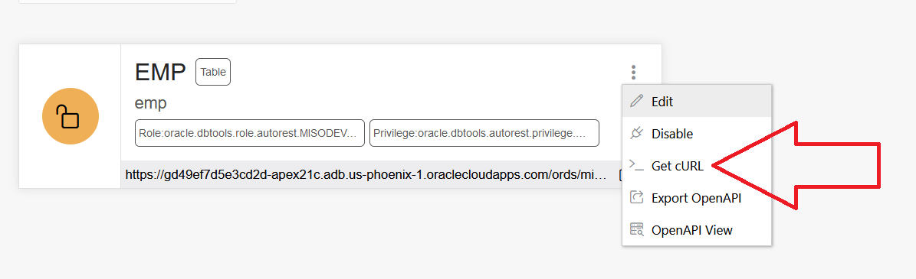

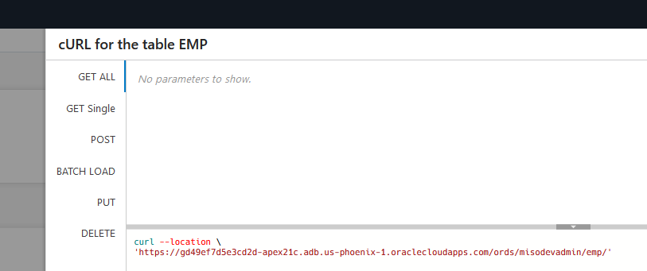

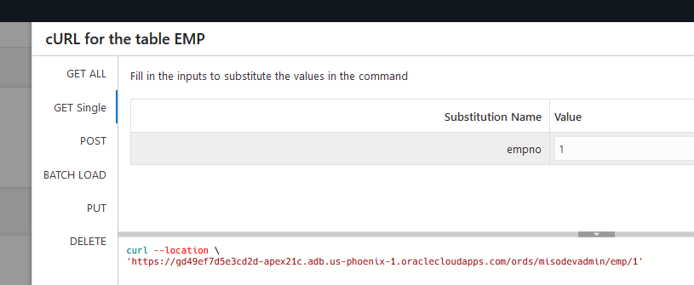

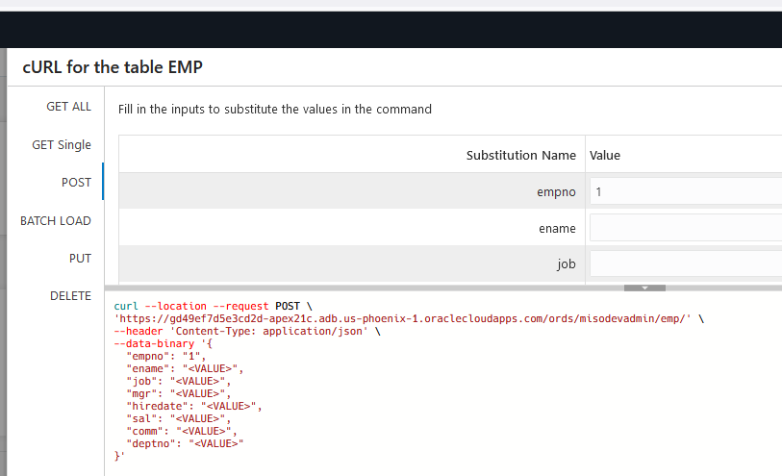

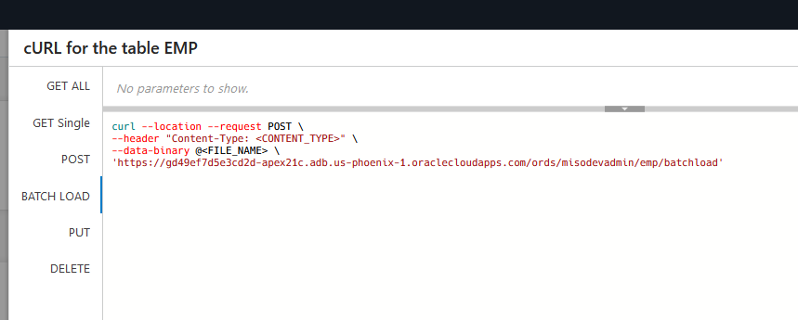

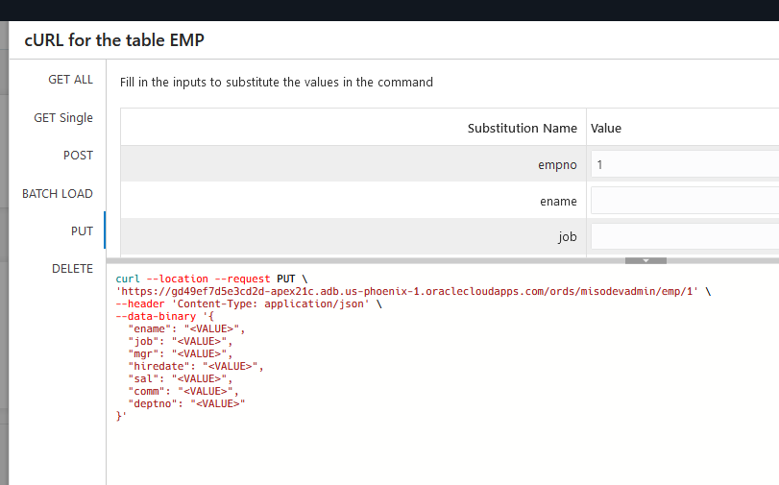

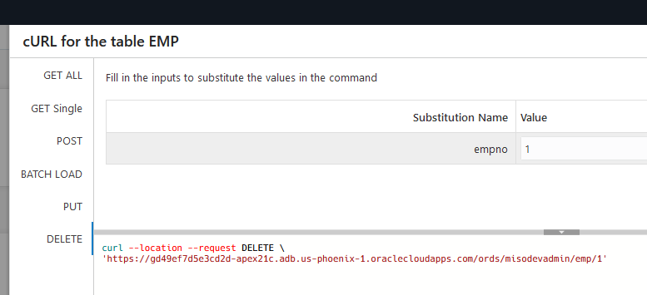

C:\Users\rmand>curl --location "https://gd49ef7d5e3cd2d-apex21c.adb.us-phoenix-1.oraclecloudapps.com/ords/misodevadmin/emp/" --ssl-no-revoke

C:\Users\rmand>curl --location "https://gd49ef7d5e3cd2d-apex21c.adb.us-phoenix-1.oraclecloudapps.com/ords/misodevadmin/emp/" --ssl-no-revoke > a.a

% Total % Received % Xferd Average Speed Time Time Time Current

Dload Upload Total Spent Left Speed

100 4148 0 4148 0 0 4148 0 --:--:-- --:--:-- --:--:-- 8863

C:\Users\rmand>type a.a

{"items":[{"empno":7839,"ename":"KING","job":"PRESIDENT","mgr":null,"hiredate":"1981-11-17T00:00:00Z","sal":5000,"comm":null,"deptno":10,"links":[{"rel":"self","href":"https://gd49ef7d5e3cd2d-apex21c.adb.us-phoenix-1.oraclecloudapps.com/ords/misodevadmin/emp/7839"}]},{"empno":7698,"ename":"BLAKE","job":"MANAGER","mgr":7839,"hiredate":"1981-05-01T00:00:00Z","sal":2850,"comm":null,"deptno":30,"links":[{"rel":"self","href":"https://gd49ef7d5e3cd2d-apex21c.adb.us-phoenix-1.oraclecloudapps.com/ords/misodevadmin/emp/7698"}]},{"empno":7782,"ename":"CLARK","job":"MANAGER","mgr":7839,"hiredate":"1981-06-09T00:00:00Z","sal":2450,"comm":null,"deptno":10,"links":[{"rel":"self","href":"https://gd49ef7d5e3cd2d-apex21c.adb.us-phoenix-1.oraclecloudapps.com/ords/misodevadmin/emp/7782"}]},{"empno":7566,"ename":"JONES","job":"MANAGER","mgr":7839,"hiredate":"1981-04-02T00:00:00Z","sal":2975,"comm":null,"deptno":20,"links":[{"rel":"self","href":"https://gd49ef7d5e3cd2d-apex21c.adb.us-phoenix-1.oraclecloudapps.com/ords/misodevadmin/emp/7566"}]},{"empno":7788,"ename":"SCOTT","job":"ANALYST","mgr":7566,"hiredate":"1982-12-09T00:00:00Z","sal":3000,"comm":null,"deptno":20,"links":[{"rel":"self","href":"https://gd49ef7d5e3cd2d-apex21c.adb.us-phoenix-1.oraclecloudapps.com/ords/misodevadmin/emp/7788"}]},{"empno":7902,"ename":"FORD","job":"ANALYST","mgr":7566,"hiredate":"1981-12-03T00:00:00Z","sal":3000,"comm":null,"deptno":20,"links":[{"rel":"self","href":"https://gd49ef7d5e3cd2d-apex21c.adb.us-phoenix-1.oraclecloudapps.com/ords/misodevadmin/emp/7902"}]},{"empno":7369,"ename":"SMITH","job":"CLERK","mgr":7902,"hiredate":"1980-12-17T00:00:00Z","sal":800,"comm":null,"deptno":20,"links":[{"rel":"self","href":"https://gd49ef7d5e3cd2d-apex21c.adb.us-phoenix-1.oraclecloudapps.com/ords/misodevadmin/emp/7369"}]},{"empno":7499,"ename":"ALLEN","job":"SALESMAN","mgr":7698,"hiredate":"1981-02-20T00:00:00Z","sal":1600,"comm":300,"deptno":30,"links":[{"rel":"self","href":"https://gd49ef7d5e3cd2d-apex21c.adb.us-phoenix-1.oraclecloudapps.com/ords/misodevadmin/emp/7499"}]},{"empno":7521,"ename":"WARD","job":"SALESMAN","mgr":7698,"hiredate":"1981-02-22T00:00:00Z","sal":1250,"comm":500,"deptno":30,"links":[{"rel":"self","href":"https://gd49ef7d5e3cd2d-apex21c.adb.us-phoenix-1.oraclecloudapps.com/ords/misodevadmin/emp/7521"}]},{"empno":7654,"ename":"MARTIN","job":"SALESMAN","mgr":7698,"hiredate":"1981-09-28T00:00:00Z","sal":1250,"comm":1400,"deptno":30,"links":[{"rel":"self","href":"https://gd49ef7d5e3cd2d-apex21c.adb.us-phoenix-1.oraclecloudapps.com/ords/misodevadmin/emp/7654"}]},{"empno":7844,"ename":"TURNER","job":"SALESMAN","mgr":7698,"hiredate":"1981-09-08T00:00:00Z","sal":1500,"comm":0,"deptno":30,"links":[{"rel":"self","href":"https://gd49ef7d5e3cd2d-apex21c.adb.us-phoenix-1.oraclecloudapps.com/ords/misodevadmin/emp/7844"}]},{"empno":7876,"ename":"ADAMS","job":"CLERK","mgr":7788,"hiredate":"1983-01-12T00:00:00Z","sal":1100,"comm":null,"deptno":20,"links":[{"rel":"self","href":"https://gd49ef7d5e3cd2d-apex21c.adb.us-phoenix-1.oraclecloudapps.com/ords/misodevadmin/emp/7876"}]},{"empno":7900,"ename":"JAMES","job":"CLERK","mgr":7698,"hiredate":"1981-12-03T00:00:00Z","sal":950,"comm":null,"deptno":30,"links":[{"rel":"self","href":"https://gd49ef7d5e3cd2d-apex21c.adb.us-phoenix-1.oraclecloudapps.com/ords/misodevadmin/emp/7900"}]},{"empno":7934,"ename":"MILLER","job":"CLERK","mgr":7782,"hiredate":"1982-01-23T00:00:00Z","sal":1300,"comm":null,"deptno":10,"links":[{"rel":"self","href":"https://gd49ef7d5e3cd2d-apex21c.adb.us-phoenix-1.oraclecloudapps.com/ords/misodevadmin/emp/7934"}]}],"hasMore":false,"limit":25,"offset":0,"count":14,"links":[{"rel":"self","href":"https://gd49ef7d5e3cd2d-apex21c.adb.us-phoenix-1.oraclecloudapps.com/ords/misodevadmin/emp/"},{"rel":"edit","href":"https://gd49ef7d5e3cd2d-apex21c.adb.us-phoenix-1.oraclecloudapps.com/ords/misodevadmin/emp/"},{"rel":"describedby","href":"https://gd49ef7d5e3cd2d-apex21c.adb.us-phoenix-1.oraclecloudapps.com/ords/misodevadmin/metadata-catalog/emp/"},{"rel":"first","href":"https://gd49ef7d5e3cd2d-apex21c.adb.us-phoenix-1.oraclecloudapps.com/ords/misodevadmin/emp/"}]}

**Task 2: REST Enabling the Database Objects, the RIGHT WAY**

Running the SQL Script below will REST Enable the schema and also create modules for the EMP and DEPT tables and the EMP_DEPT_V view, together with the appropriate handlers.

Alternatively, you could go to SQL Workshop > RESTful Services and REST enabled the schema. Then go to SQL Workshop > Object Browser, clicked on each table/view and then selected REST to define the REST services. However, the handlers created using the SQL Workshop > Object Browser will utilize Data Dictionary lookups each time they are called. This is less efficient then the manually created services you will create, especially on services, such as apex.oracle.com, which have an extremely large data dictionary. On apex.oracle.com there are over 20,000 schemas.

1. In the main menu, select **SQL Workshop**, click **SQL Scripts**.

1. On the SQL Scripts page, click **Create**.

|  |
| --- |
| begin  ords.enable_schema;  end;  /  begin  ords.delete_module(  p_module_name => 'emp.rest' );  ords.define_module(  p_module_name => 'emp.rest',  p_base_path => '/emp/' );  ords.define_template(  p_module_name => 'emp.rest',  p_pattern => 'hol/' );  ords.define_template(  p_module_name => 'emp.rest',  p_pattern => 'hol/:empno' );  ords.define_handler(  p_module_name => 'emp.rest',  p_pattern => 'hol/',  p_method => 'GET',  p_source_type => ords.source_type_collection_feed,  p_source => 'select * from emp' );  ords.define_handler(  p_module_name => 'emp.rest',  p_pattern => 'hol/:empno',  p_method => 'GET',  p_source_type => ords.source_type_collection_item,  p_source => 'select * from emp where empno = :empno' );  ords.define_handler(  p_module_name => 'emp.rest',  p_pattern => 'hol/',  p_method => 'POST',  p_source_type => ords.source_type_plsql,  p_source => 'begin insert into emp (empno, ename, job, mgr, hiredate, sal, comm, deptno) values (:empno,:ename,:job,:mgr,:hiredate,:sal,:comm,:deptno);:forward_location:=:empno;:status_code:=201;end;' );  ords.define_handler(  p_module_name => 'emp.rest',  p_pattern => 'hol/:empno',  p_method => 'PUT',  p_source_type => ords.source_type_plsql,  p_source => 'begin update emp set ename=:ename,job=:job,mgr=:mgr,hiredate=:hiredate,sal=:sal,comm=:comm,deptno=:deptno where empno=:empno; :forward_location:=:empno;:status_code:=200;end;' );  ords.define_handler(  p_module_name => 'emp.rest',  p_pattern => 'hol/:empno',  p_method => 'DELETE',  p_source_type => ords.source_type_plsql,  p_source => 'begin delete emp where empno=:empno;:status_code:=200;end;' );  end;  /  begin  ords.delete_module(  p_module_name => 'dept.rest' );  ords.define_module(  p_module_name => 'dept.rest',  p_base_path => '/dept/' );  ords.define_template(  p_module_name => 'dept.rest',  p_pattern => 'hol/' );  ords.define_template(  p_module_name => 'dept.rest',  p_pattern => 'hol/:deptno' );  ords.define_handler(  p_module_name => 'dept.rest',  p_pattern => 'hol/',  p_method => 'GET',  p_source_type => ords.source_type_collection_feed,  p_source => 'select * from dept' );  ords.define_handler(  p_module_name => 'dept.rest',  p_pattern => 'hol/:deptno',  p_method => 'GET',  p_source_type => ords.source_type_collection_item,  p_source => 'select * from dept where deptno = :deptno' );  ords.define_handler(  p_module_name => 'dept.rest',  p_pattern => 'hol/',  p_method => 'POST',  p_source_type => ords.source_type_plsql,  p_source => 'begin insert into dept (deptno, dname, loc) values (:deptno,:dname,:loc);:forward_location:=:deptno;:status_code:=201;end;' );  ords.define_handler(  p_module_name => 'dept.rest',  p_pattern => 'hol/:deptno',  p_method => 'PUT',  p_source_type => ords.source_type_plsql,  p_source => 'begin update dept set dname=:dname,loc=:loc where deptno=:deptno; :forward_location:=:deptno;:status_code:=200;end;' );  ords.define_handler(  p_module_name => 'dept.rest',  p_pattern => 'hol/:deptno',  p_method => 'DELETE',  p_source_type => ords.source_type_plsql,  p_source => 'begin delete dept where deptno=:deptno;:status_code:=200;end;' );  end;  /  begin  ords.delete_module(  p_module_name => 'empdeptv.rest' );  ords.define_module(  p_module_name => 'empdeptv.rest',  p_base_path => '/empdeptv/' );  ords.define_template(  p_module_name => 'empdeptv.rest',  p_pattern => 'hol/' );  ords.define_template(  p_module_name => 'empdeptv.rest',  p_pattern => 'hol/:empno' );  ords.define_handler(  p_module_name => 'empdeptv.rest',  p_pattern => 'hol/',  p_method => 'GET',  p_source_type => ords.source_type_collection_feed,  p_source => 'select * from emp_dept_v' );  ords.define_handler(  p_module_name => 'empdeptv.rest',  p_pattern => 'hol/:empno',  p_method => 'GET',  p_source_type => ords.source_type_collection_item,  p_source => 'select * from emp_dept_v where empno = :empno' );  end;  / |

1. In the Script Editor, enter the following.
   * **Script Name:** Enter **Define REST Endpoints for EMP and DEPT**.
   * **Script Editor:** Cut and paste the following.

Click **Run**.

1. On the Run Script page, click **Run Now**.
2. Results should show 4 statements processed successfully.

**Task 3: Reviewing the REST Services**

1. In the main menu, select **SQL Workshop**, click **RESTful Services**.

1. In the ORDS RESTful Services page,

1. expand **Modules**, expand **emp.rest**, and then expand **hol/**.  
   Click on **GET**.

Click on the Copy to Clipboard icon (or manually copy the Full URL).

1. Open a new tab/window in your browser and paste the Full URL. Keep this tab open or make a note of this URL because you will need it later.

*Note: Depending on your browser you may just see the raw JSON document rather than the formatted output displayed above.*